Hello Matthew,
Currently, we do not have phone support in place, but we are more than happy to answer any questions via e-mail or through the help portion of our web page!
When creating our company, we decided to not offer phone support because it requires a different type of interaction than what our teaching method is currently built around. We take all student questions very seriously and strive to answer them quickly and accurately through our help/e-mail support. If we offered phone support, that would come with a large wait time and a significant increase to the price of the course.
We hope you understand that we work this way to create the best experience for all of our students without creating a high cost for entry. We are always here to answer any questions you might have! Our online teachers are available from 7AM to 11PM EST six days a week and are always happy to help!
We're sorry about your mod troubles! No need to worry though - we're here to help!
I think the best way to get you back on track is by looking at your .mod file. To help you with the process of sending your file, you can watch the video below!

How To Attach Your Mod Video
We've also included the directions below to follow along!
Make sure you've closed out of Eclipse, and ModManager has saved your most recent work.
- Click on the Attach button in your next message.
- Navigate to the following folder: Desktop\Youth Digital\Mod Design 1\
- Click on your .mod file and press Open.
- Now your file will be attached to this message! Before sending make sure the file fully attaches to the message.
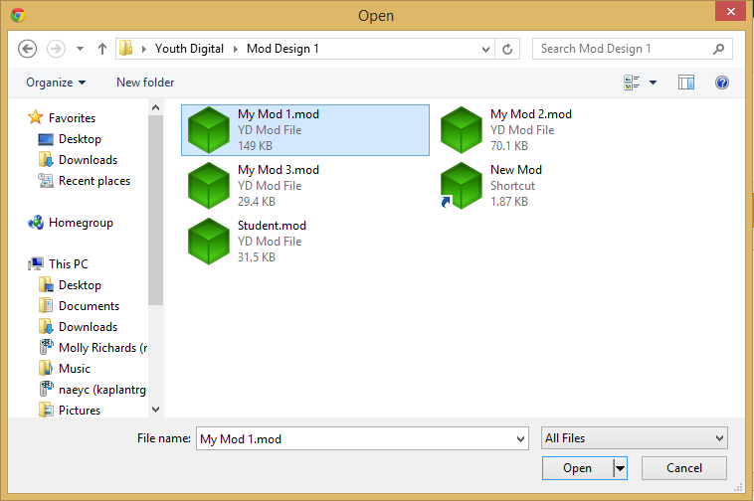
This will allow us to look at your mod file on my end to see what the problem is! If you have any errors in your mod, you should leave them in your mod so that we can see where things went wrong.
Thanks so much!

